**PART A) Download and Install Virtual Box**

Download Virtual box using this [li](https://www.virtualbox.org/wiki/Downloads) nk

Depending on your processor and OS, select the appropriate package. In our case, we have selected Windows with AMD

[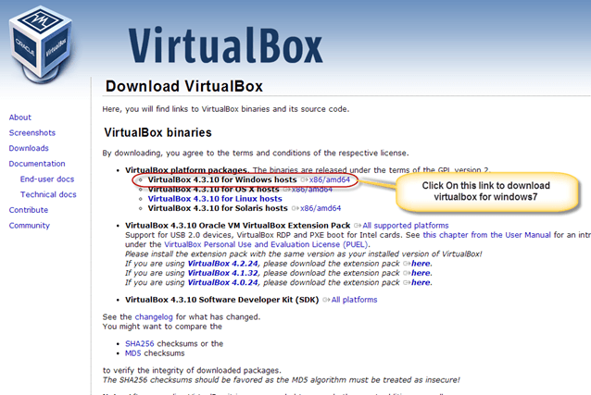](https://www.guru99.com/images/Big_Data/061114_1146_Ubuntuinsta2.png)

Once the download is complete, Open setup file and follow the steps below:

**Step-1)** Click On next

[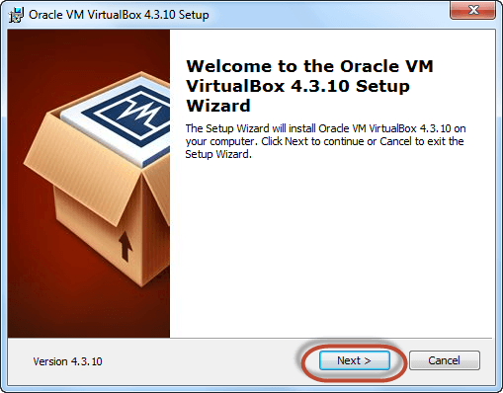](https://www.guru99.com/images/Big_Data/061114_1146_Ubuntuinsta3.png)

**Step-2)** Select you're the directory to install VirtualBox and click on next

[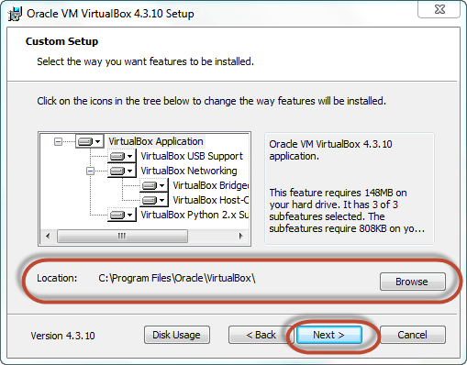](https://www.guru99.com/images/Big_Data/061114_1146_Ubuntuinsta4.png)

**Step-3)** Select Desktop icon and click on next, now click on yes

[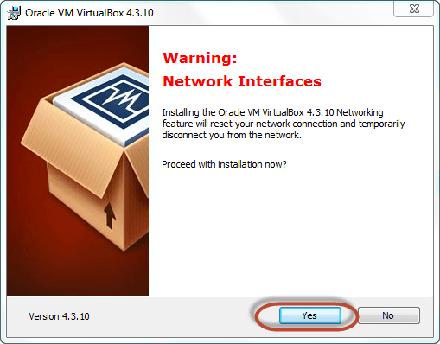](https://www.guru99.com/images/Big_Data/061114_1146_Ubuntuinsta5.png)

**Step-4)** Click On install.

[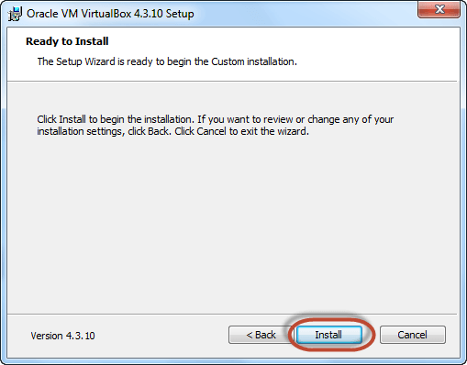](https://www.guru99.com/images/Big_Data/061114_1146_Ubuntuinsta6.png)

**Step-5)** Now installation of the virtual box will start. Once complete, click on Finish Button to start Virtual Box

[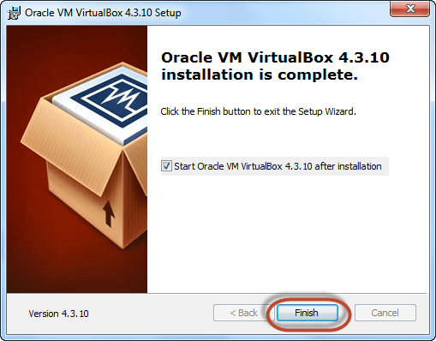](https://www.guru99.com/images/Big_Data/061114_1146_Ubuntuinsta7.png)

The virtual box dashboard looks like this-

[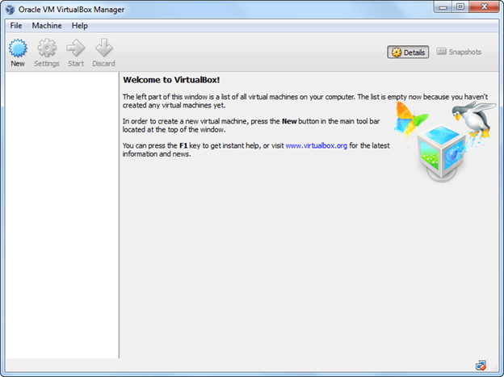](https://www.guru99.com/images/Big_Data/061114_1146_Ubuntuinsta8.png)

**PART B) Download Ubuntu**

Visit this link to [download](http://www.ubuntu.com/download/desktop) Ubuntu.

[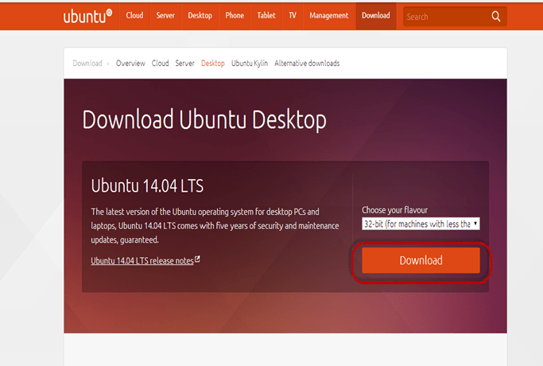](https://www.guru99.com/images/Big_Data/061114_1146_Ubuntuinsta9.png)

You can select 32/64-bit versions as per your choice.

**PART C) Create a Machine in Virtual Box**

**Step-1)** Open Virtual box and click on new button

[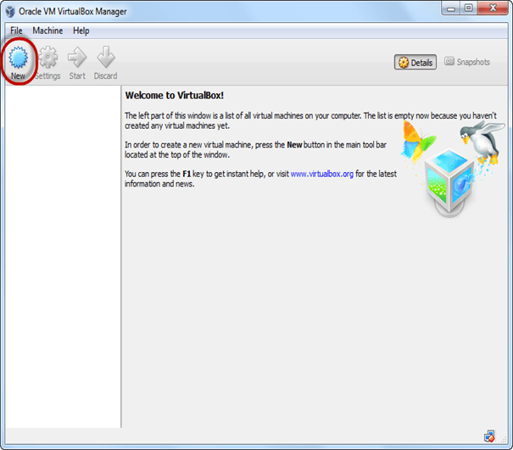](https://www.guru99.com/images/Big_Data/061114_1146_Ubuntuinsta10.png)

**Step-2)** In next window**,** give the name of your OS which you are installing in virtual box. And select OS like [Linux](https://www.guru99.com/unix-linux-tutorial.html) and version as Ubuntu 32 bit. And click on next

[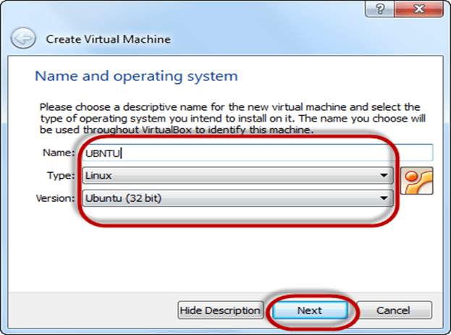](https://www.guru99.com/images/Big_Data/061114_1146_Ubuntuinsta11.png)

**Step-3)** Now Allocate Ram Size To your Virtual OS. I recommended keeping 1024mb (1 GB) ram to run Ubuntu better. And click on next.

[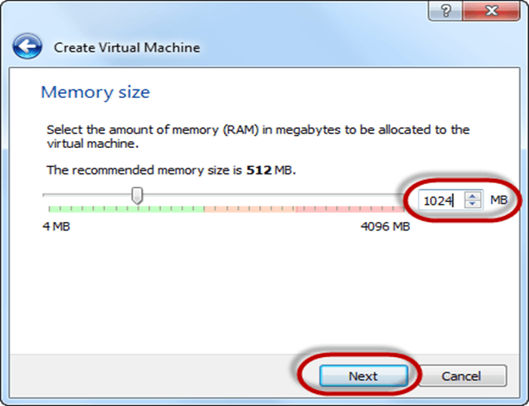](https://www.guru99.com/images/Big_Data/061114_1146_Ubuntuinsta12.png)

**Step-4)** Now To run OS in virtual box we have to create virtual hard disk, click on create a virtual hard drive now and click on create button. The virtual hard disk is where the OS installation files and data/applications you create/install in this Ubuntu machine will reside

[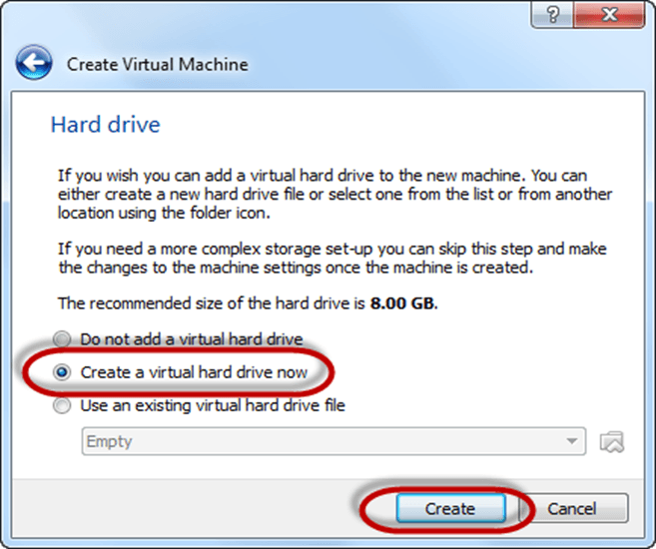](https://www.guru99.com/images/Big_Data/061114_1146_Ubuntuinsta13.png)

**Step-5)** select VHD (virtual hard disk) option and click on next.

[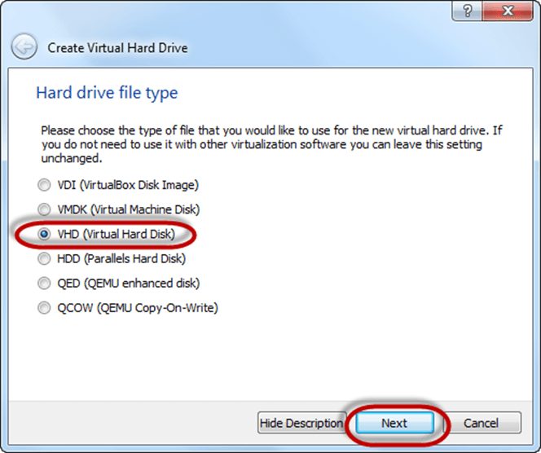](https://www.guru99.com/images/Big_Data/061114_1146_Ubuntuinsta14.png)

**Step-6)** Click on dynamic allocated and click on next. This means that the size of the disk will increase dynamically as per requirement.

[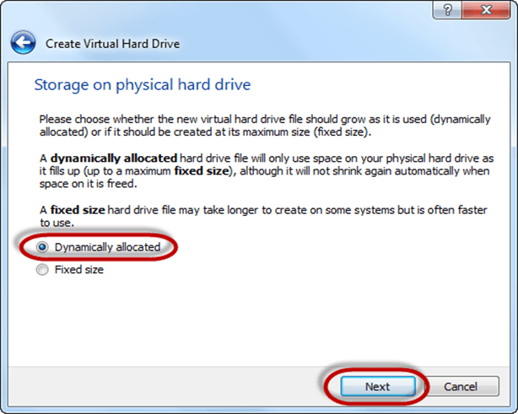](https://www.guru99.com/images/Big_Data/061114_1146_Ubuntuinsta15.png)

**Step-7)** Allocate memory to your virtual hard drive .8GB recommended. Click on create button.

[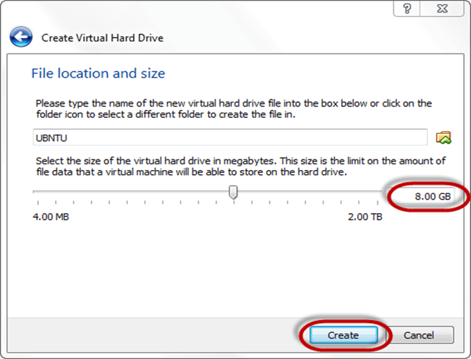](https://www.guru99.com/images/Big_Data/061114_1146_Ubuntuinsta16.png)

**Step-8)** Now you can see the machine name in left panel

[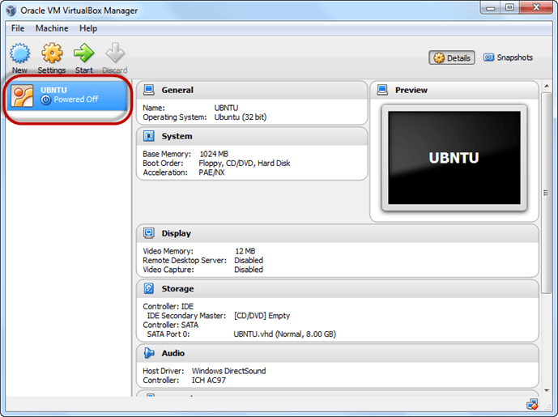](https://www.guru99.com/images/Big_Data/061114_1146_Ubuntuinsta17.png)

So a Machine (PC) with 8GB Hardisk, 1GB RAM is ready.

**PART D) Install Ubuntu on the Machine**

**Step 1**) Select the Machine and Click on Start

[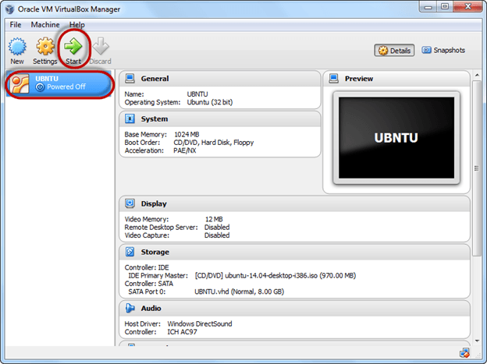](https://www.guru99.com/images/Big_Data/061114_1146_Ubuntuinsta18.png)

**Step 2)** Select the Folder Option

[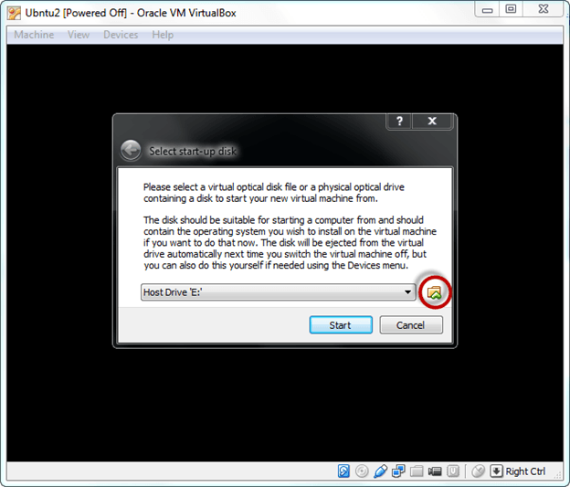](https://www.guru99.com/images/Big_Data/061114_1146_Ubuntuinsta19.png)

**Step 3)** Select the Ubuntu iso file

[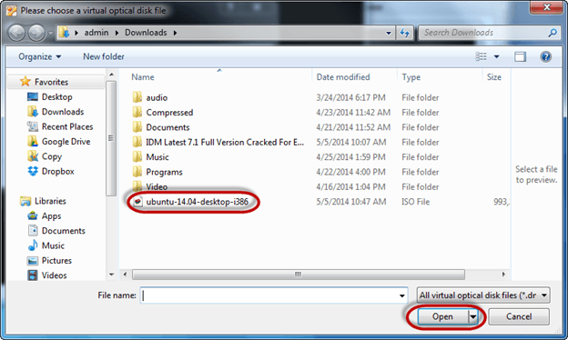](https://www.guru99.com/images/Big_Data/061114_1146_Ubuntuinsta20.png)

**Step 4)** Click Start

[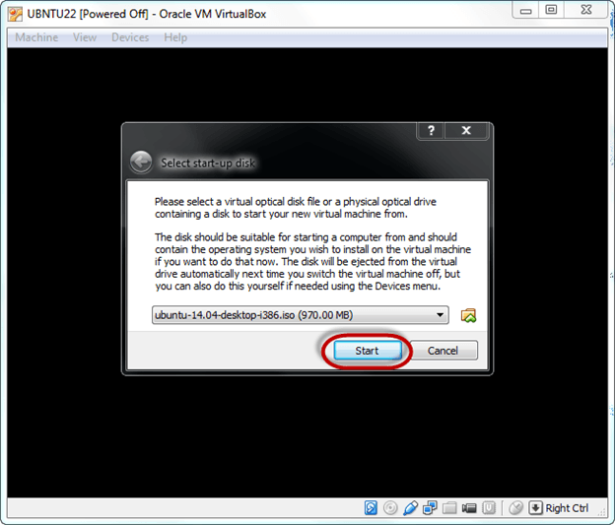](https://www.guru99.com/images/Big_Data/061114_1146_Ubuntuinsta21.png)

**Step-5)** You have an option to Run Ubuntu WITHOUT installing. In this tutorial will install Ubuntu

[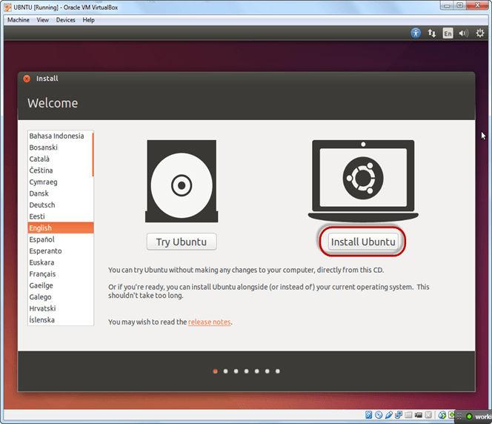](https://www.guru99.com/images/Big_Data/061114_1146_Ubuntuinsta22.png)

**Step-6)** Click continue.

[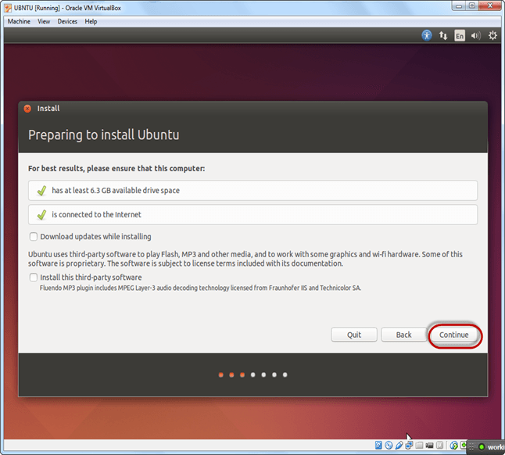](https://www.guru99.com/images/Big_Data/061114_1146_Ubuntuinsta23.png)

**Step-7)** Select option to erase the disk and install Ubuntu and click on install now. This option installs Ubuntu into our virtual hard drive which is we made earlier. It will not harm your PC or Windows installation

[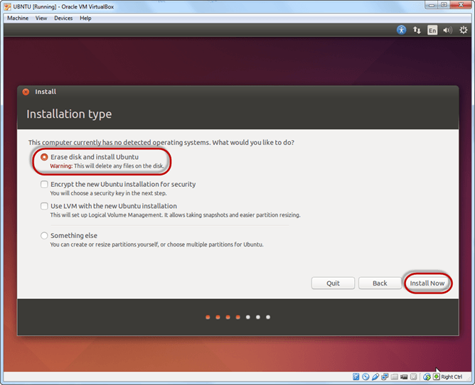](https://www.guru99.com/images/Big_Data/061114_1146_Ubuntuinsta24.png)

**Step-8)** Select your location for setting up time zone, and click on continue

[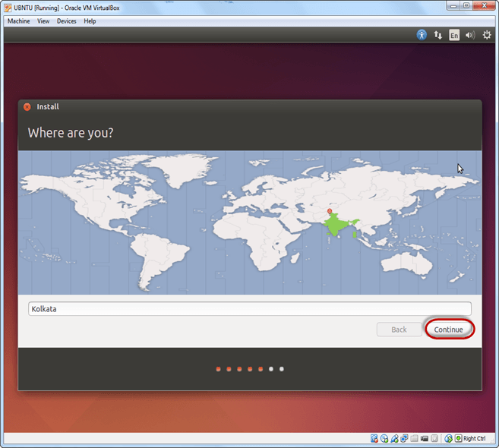](https://www.guru99.com/images/Big_Data/061114_1146_Ubuntuinsta25.png)

**Step-9)** Select your keyboard layout, by default English (US) is selected but if you want to change then, you can select in the list. And click on continue

[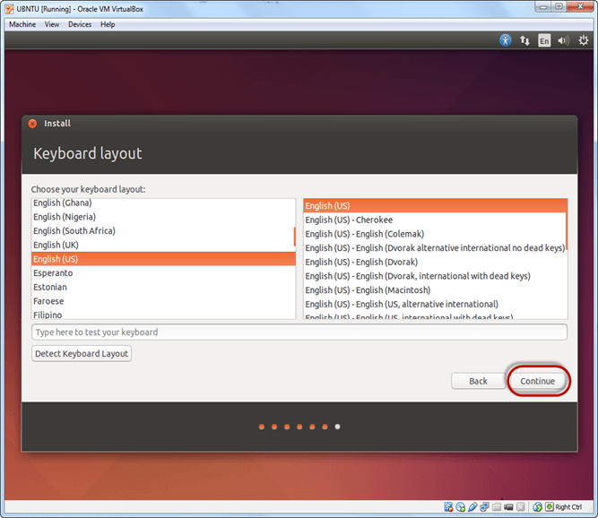](https://www.guru99.com/images/Big_Data/061114_1146_Ubuntuinsta26.png)

**Step-10)** Select your username and password for your Ubuntu admin account. This information has been needed for installing any software package into Ubuntu and also for login to your OS. Fill up your details and tick on login automatically to ignore login attempt and click on continue

[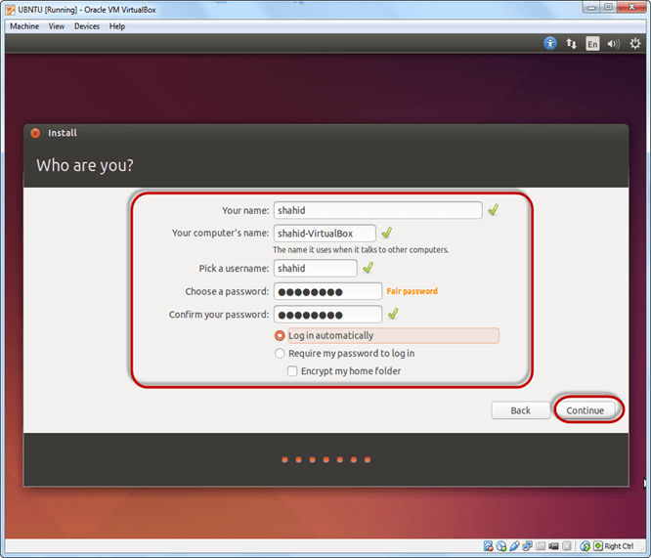](https://www.guru99.com/images/Big_Data/061114_1146_Ubuntuinsta27.png)

**Step-11)** Installation process starts. May take up to 30 minutes. Please wait until installation process completes.

[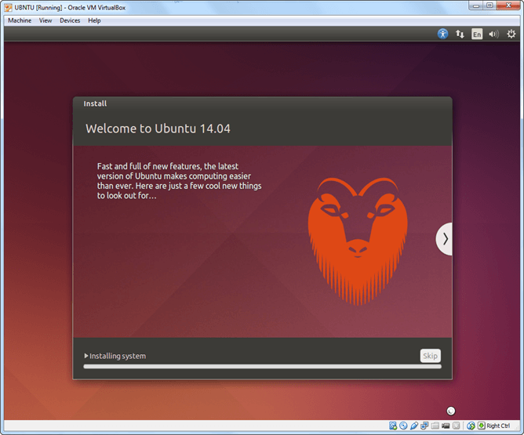](https://www.guru99.com/images/Big_Data/061114_1146_Ubuntuinsta28.png)

**Step-12)** After finishing the installation, you will see Ubuntu Desktop.

[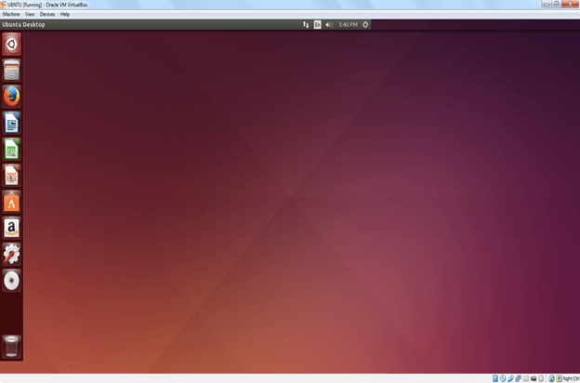](https://www.guru99.com/images/Big_Data/061114_1146_Ubuntuinsta29.png)